**Suniy intelekt. 1-dedlain.**

|  |  |  |
| --- | --- | --- |
| **Talabaning HEMIS bo‘yicha o‘rni** | **Talabaning FISH** | **Talabaning guruhi** |
| 23 | Yunusov Elmurod | 641-23 |

**1-topshiriq**

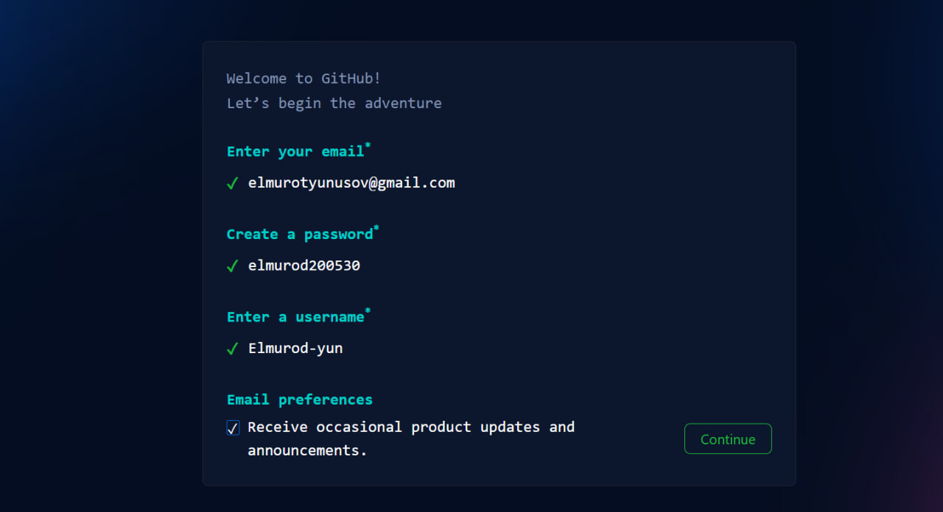



**Git Hub ga o'z emailim bilan ro'yhatdan o'tib oldim.Keyin esa o'zim uchun yangi repstiry yaratib oldim.**

**2-topshiriq**

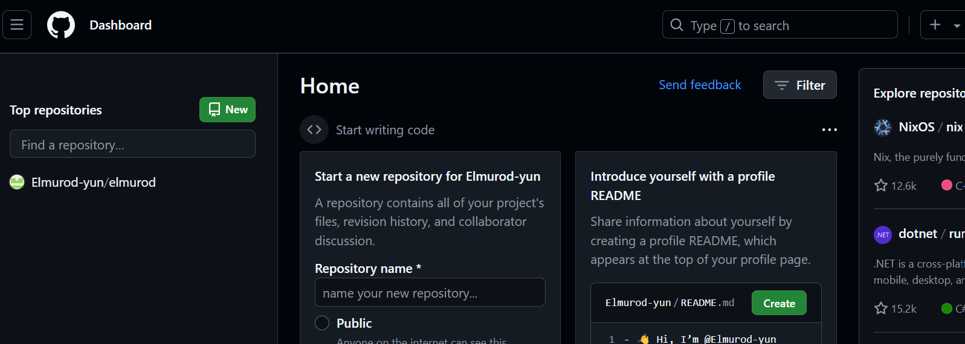

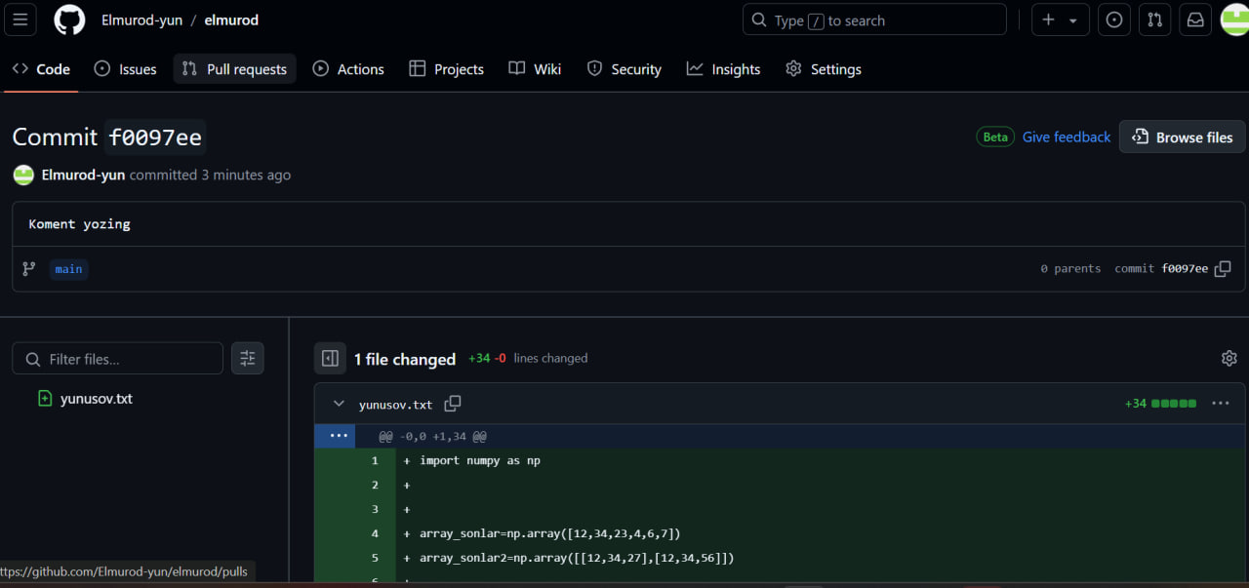

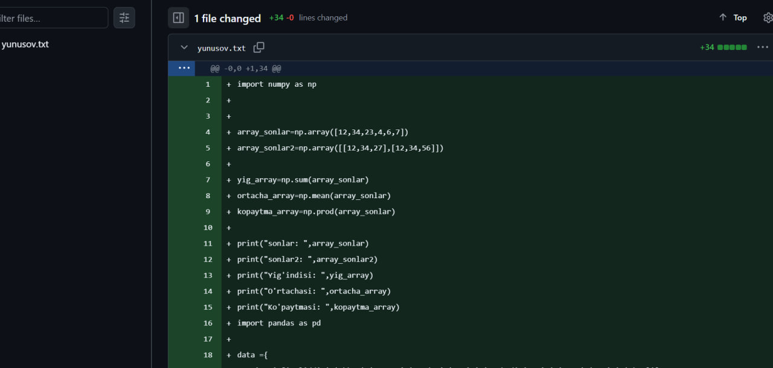

3-topshiriq

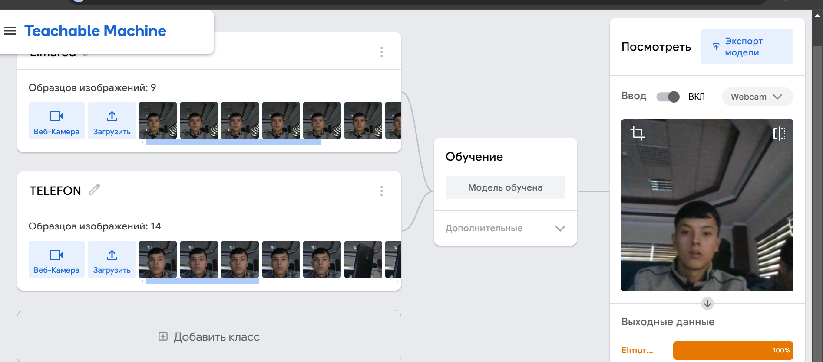

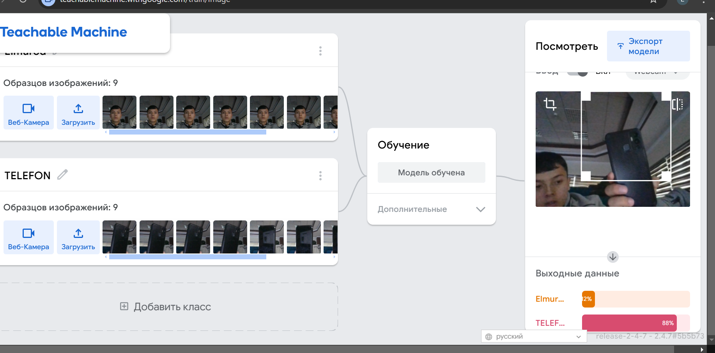

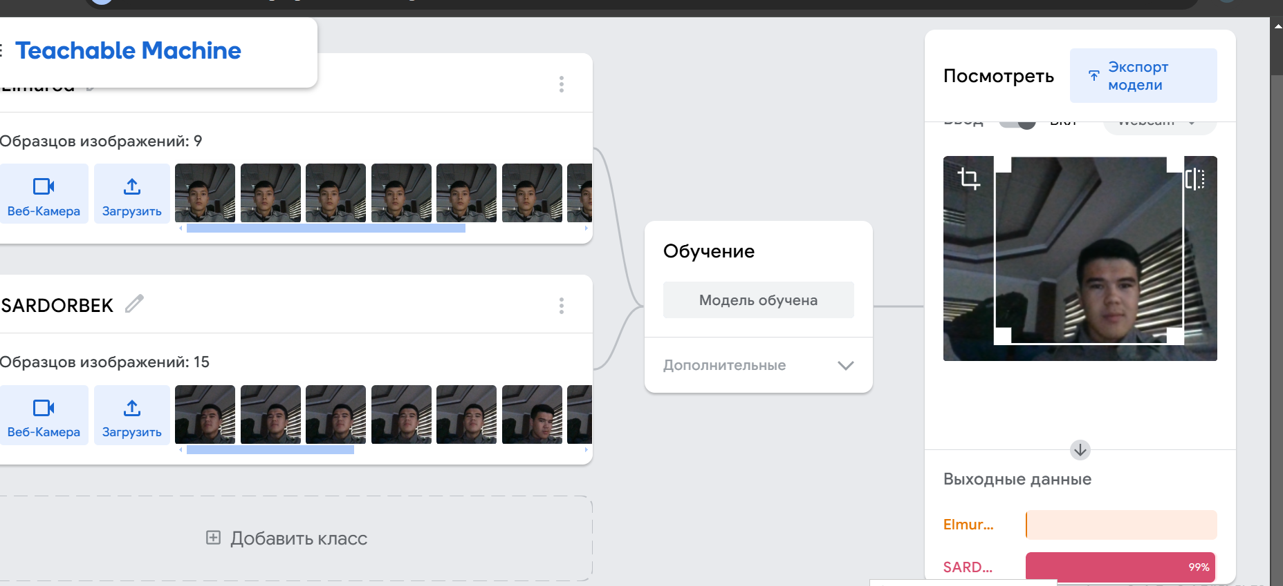

4-topshiriq

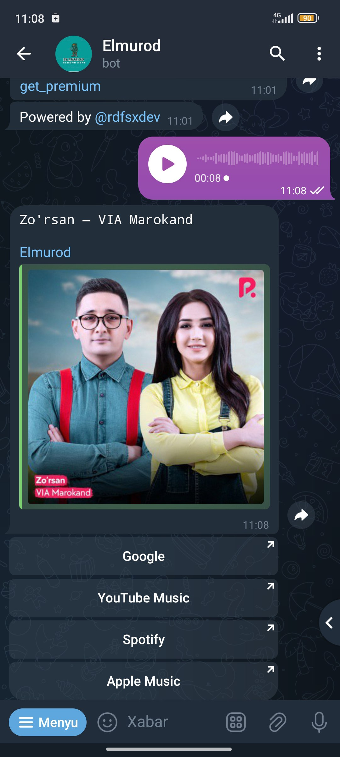

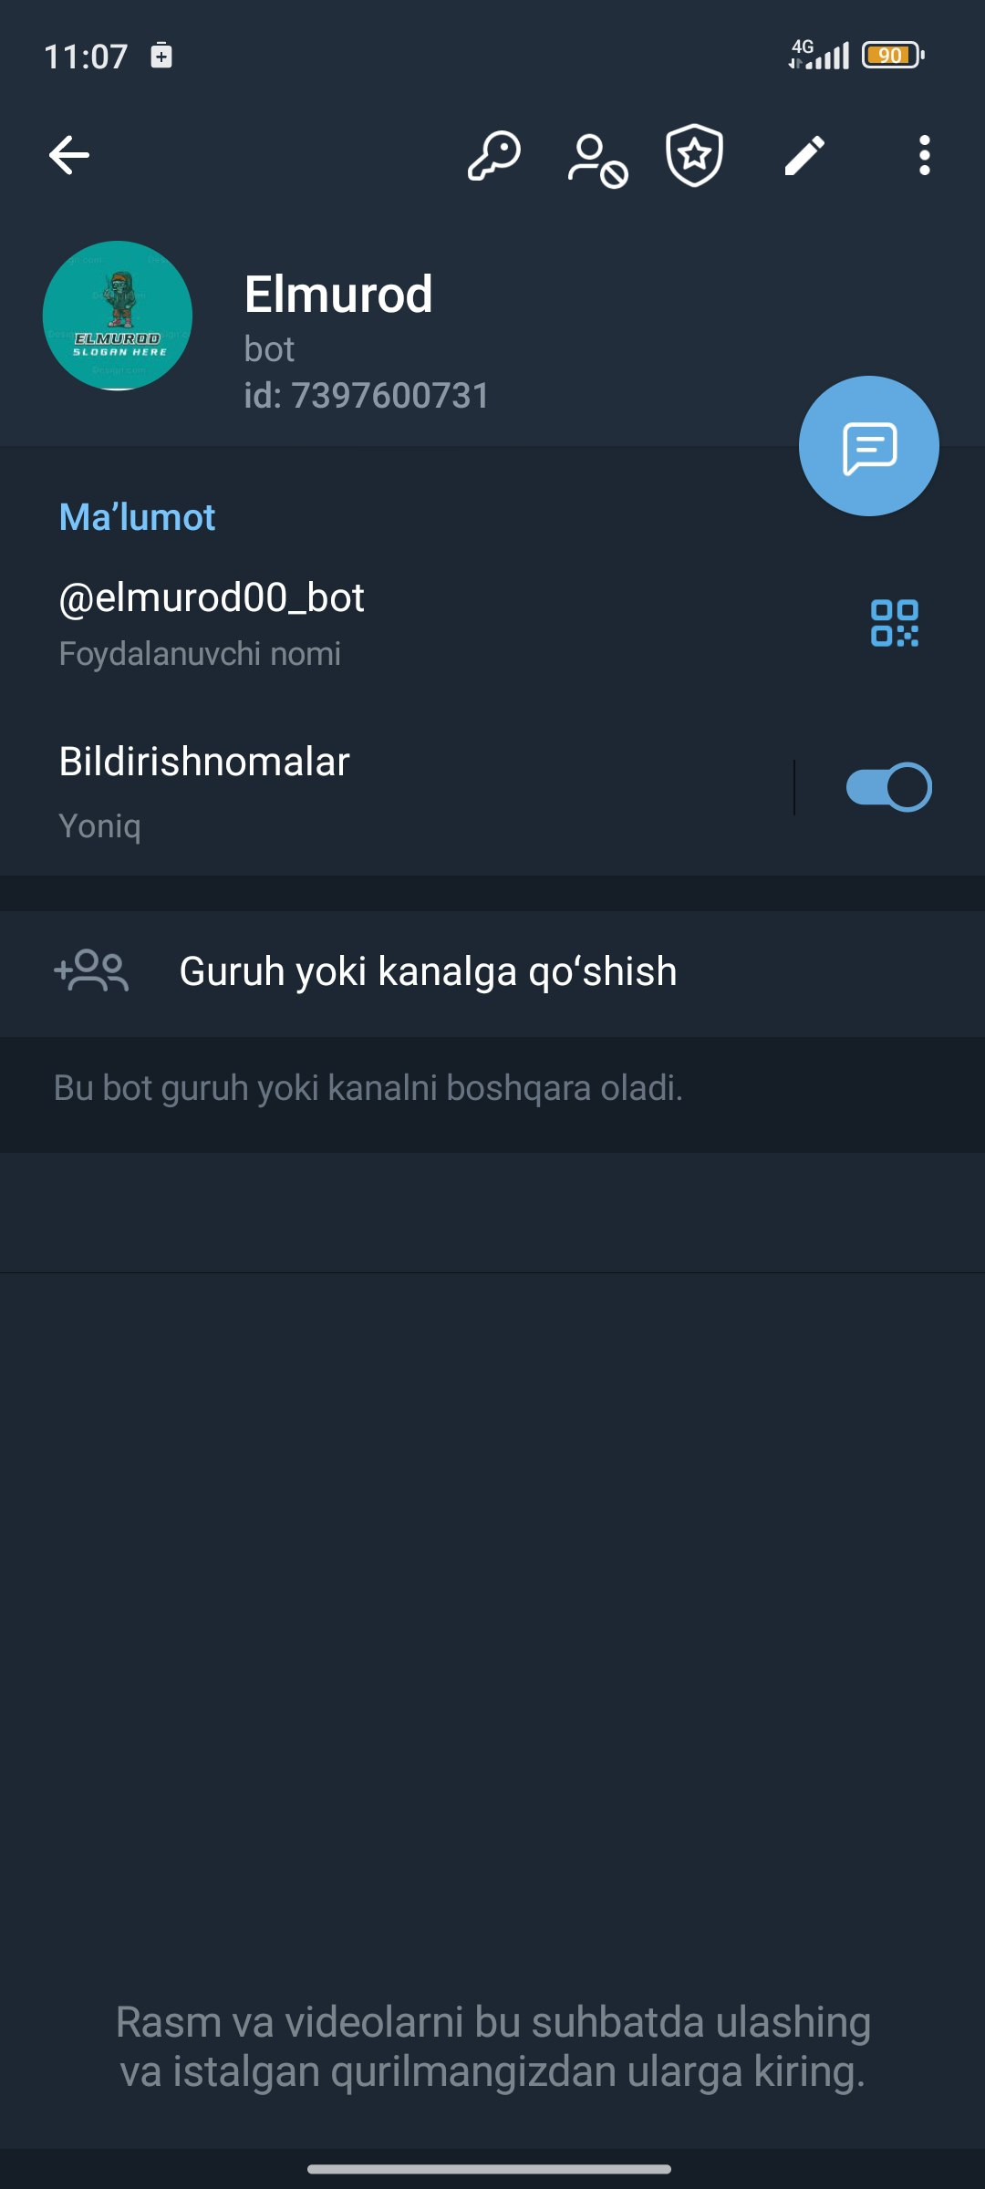

5-topshiriq

